**MANAGEMENT OF THROMBOPROPHYLAXIS IN PREGNANCY AND**

# THE PEURPERIUM

|  |  |
| --- | --- |
| Full title: | Management of thromboprophylaxis in pregnancy and the puerperium |
| Author | Tasrina Akter (tasrina.akter@nhs.net) |
| Scope (Target audience) | GP, Obstetricians, midwives, haematologists, anaesthetists |
| Review date | October 2025 |
| patient group to which it applies | This guideline should be applied to all pregnant women to assess risk of VTE during pregnancy and post-delivery. |
| NICE guideline reference | N/A |
| Summary of evidence base this guideline has been created from | RCOG guideline 37a |

|  |  |
| --- | --- |
| **Contents** |  |
| 1. Introduction | 2 |
| 2. Antenatal VTE risk assessment | 2-4 |
| 3. VTE risk factors | 4-5 |
| 4. Thrombophilia testing image: flow chart | 5-7 |
| 5. Intrapartum considerations | 7-9 |
| 6. Postnatal VTE risk assessment | 9-11 |
| 7. Referrals | 11 |
| 8. Checklist for starting LMWH in antenatal clinic | 11-12 |
| 9. References | 12 |
| 10. Appendix 1 | 13 |
| 11. Appendix 2 | 14 |
| 12. Appendix 3 | 15 |
| 13. Appendix 4 | 16 |
| 14. Appendix 5 | 17 |

**1. Introduction:**

Venous thromboembolism (VTE) refers to the formation of a clot within veins. This can occur anywhere in the venous system but the predominant sites are deep vein thrombosis (DVT) and pulmonary embolism (PE). PE remains a leading direct cause of maternal death in the UK.

Although the relative risk of VTE in pregnancy is increased four- to six-fold and this is increased further in the postpartum period; the absolute risk remains low with an overall incidence of VTE in pregnancy and the puerperium of 1-2 per 1000.

A risk stratified approach to pharmacological thromboprophylaxis is therefore required. This guideline supports the management of women requiring LMWH (low molecular weight heparin) thromboprophylaxis.

**2. Antenatal VTE risk assessment**

All women who are pregnant require a risk assessment for VTE; this is available in the RCOG green-top guideline 37a (appendix 1 and 2).

All women should receive a patient information leaflet on VTE risk in pregnancy at booking.

Risk assessment should be performed routinely:

* At booking
* At 28 weeks
* Immediately postpartum
* On admission to hospital (see appendix 4); all women admitted to hospital during pregnancy or the puerperium should be considered for LMWH unless there is a contraindication.
* Any change in the clinical situation; for example, hyperemesis, ovarian hyperstimulation, active medical co-morbidities or intercurrent illness.

## Table 1: Antenatal VTE score

|  |  |
| --- | --- |
| Antenatal VTE score | Action |
| 4 or more* | Offer antenatal and postnatal LMWH; Refer to an  Obstetrician for general antenatal care at booking. Women who have had previous VTE - refer to an obstetric consultant and haematologist (needs MDT) |
| 3 | LMWH should be offered from 28 weeks and for 6 weeks postnatal; refer to an Obstetric consultant |
| 0-2 | Antenatal LMWH not required; give general advice on maintenance of mobility and hydration.  Reassess if the clinical situation changes, at 28 weeks, if admitted and at delivery |

*If a woman has had a previous VTE or if they score 4 on an antenatal risk assessment, they should be referred to an Obstetrician to consider starting LMWH as soon as possible as well as the antenatal check up by an Obstetrician.

As most women attend antenatal clinic at 12 weeks gestation, there is a risk of VTE before they are seen by a consultant and therefore LMWH should be commenced in the community by GP.

## 2.1 LMWH dosing and contraindications

The dose of LMWH is weight dependent and based on booking weight. The appropriate dose for weight can be found on the Risk Assessment for VTE (see table 2)

### Table 2: Enoxaparin dosing

|  |  |
| --- | --- |
| **Weight (Kg)** | **Enoxaparin** |
| <50 | 20 mg OD |
| 50-90 | 40 mg OD |
| 91-130 | 60 mg OD |
| 131-170 | 80 mg OD |
| >170 | 0.6mg/Kg/day  Can be given in divided doses |

Baseline bloods (FBC/U&Es) should be reviewed, ideally prior to prescribing LMWH. However, these bloods can be within the last 6-8 weeks, as long as no clinical concern that these may have altered. lf no recent bloods are available, then LMWH can be commence depending results. It is the responsibility of the requesting clinician to check these results and alter treatment accordingly if required.

Contraindications/cautions to LMWH may be present in some patients. LMWH may be commenced in some patients on balance of bleeding vs thrombotic risk, with observation for bleeding side effects. If further advice Is required in complex patients, please discuss with haematology.

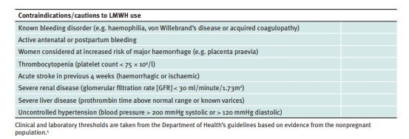

## 3. VTE risk factors

As the absolute risk of VTE in pregnancy is low, risk stratification Is required to determine which women will benefit from pharmacological thromboprophylaxis. This section is to clarify definitions of these risk factors. Please also see appendix 5 which contains FAQ document

### 3.1 Medical co-morbidities;

Some co-morbidities can increase VTE risk. This includes active issues but not quiescent medical co-morbidities. This Includes for example active cancer, heart failure, active disease; nephrotic syndrome; type1 diabetes with nephropathy; sickle cell disease; current IV drug use. This list is not exhaustive. These may be a transient additional VTE risk factor whilst medical co-morbidity is active.

Ovarian hyperstimulation syndrome (OHSS) can increase VTE risk. However, this Is only clinically relevant during the first trimester. From the second trimester onwards, this can be removed from the VTE risk assessment.

IVF pregnancies can be associated with a higher VTE risk and this therefore contributes to the antenatal VTE risk assessment score. However, this is not clinically relevant when calculating postnatal VTE risk assessment score.

### 3.2 Parity;

Parity should be calculated both antenatally and postnatally. When parity Is calculated postnatally, this should include the current delivery. This is a change to local practice, in line with the national consensus on İnterpretation of the VTE risk assessment

#### 3.3· Weight/BMI;

Booking BMl should be used when calculating VTE risk assessment antenatally. Booking weight should be used for calculation of LMWH dosing antenatally.

Postnatally, LMWH dosing should be based on a postnatal weight (please see section 6.3).

Weight gain during pregnancy is associated with an increased adjusted odd ratio of VTE if >21kg weight gain compared to weight gain of 7-21kg (a OR 1.6,95% CI 1.1-26) 2. VTE risk and LMWH dosing should therefore be reviewed and adjusted accordingly if weight gain of >21kg during the antenatal period.

##### 3.4 Family history of VTE;

This is often not clear cut, but can be assessed in any antenatal clinic; it does not require automatic referral to the obstetric haematology clinic.

Only unprovoked or oestrogen associated VTE in first degree relatives (for example parent or immediate sibling) count as risk factor. Check if diagnosis and treatment of family member is likely to fit with VTE. Use of heparin (the relative will remember using injections) is often misleading as this is given until a diagnosis is made. However, use of Warfarin or direct oral anticoagulant (DOAC) for a period of months or more is indicative of a VTE. If information on provocation is not available, then the event should be presumed to be unprovoked. Be careful to exclude cerebrovascular accidents (such as arterial stroke) and cardiac events (such as myocardial infarction); these are arterial events and are not counted as risk factors for VTE in pregnancy.

There are selected situations where thrombophilia testing is indicated for women with a first-degree family history of unprovoked or oestrogen associated VTE. Please see section 4 and image 1 for further information.

#### 4.Thrombophilia testing

Thrombophilia testing for potentially inherited conditions should only be performed if the result will alter management. Women should be counselled that a negative thrombophilia test, in the context of a relevant family history, doesn't

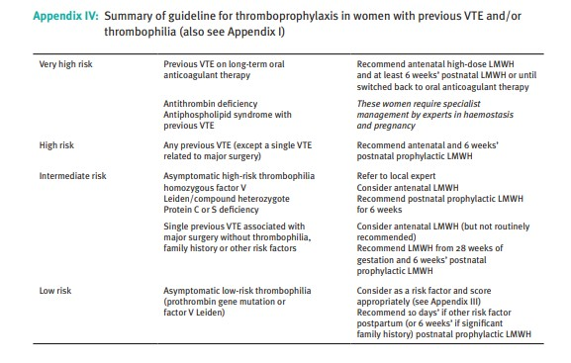

mean the risk of thrombosis is reduced. Women should also be counselled prior to testing that as these thrombophilias are inherited and a positive result might have implications for family members who may also have inherited the same condition.

Women with a family history of VTE (as described in section 3.3) need a thrombophilia screen if the results would increase their score such that they would then qualify for thromboprophylaxis with LMWH. For example, patient has VTE score=2 at 28 weeks due to family history and smoker, should be tested because if found to have a thrombophilia then VTE score would increase to >3 and hence LMWH thromboprophylaxis from 28 weeks would be indicated.

A thrombophilia screen should include; factor V Leiden, prothrombin gene mutation, protein C and antithrombin. Protein S-levels decrease in pregnancy and **should not** be tested. Please see flow-chart (image 1) below for further information and advice on follow up in the event of positive testing.

Antiphospholipid syndrome is an acquired thrombophilia an therefore family testing is **not required.**

##### 4.1 Low-risk thrombophilia;

Low-risk thrombophilia includes heterozygous factor V Leiden and heterozygous prothrombin gene mutation. The absolute increase in VTE risk associated with these thrombophilias is low and therefore these thrombophilias give an additional score of 1 on the VTE risk assessment

##### 4.2 High-risk thrombophilia;

High-risk thrombophilia includes compound heterozygous or homozygous factor V Leiden, compound heterozygous or homozygous prothrombin gene mutation, antithrombin deficiency and protein C deficiency. Pre-existing protein S deficiency is also a high-risk thrombophilia but can't be diagnosed in pregnancy due to alterations of protein S levels in normal pregnancy. As these high-risk thrombophilias are associated with a higher absolute risk of VTE, they score 3 on the VTE risk assessment

#### Image 1: thrombophilia testing flow chart

F

a

m

il

y h

i

sto

r

y of unprovoked or

Oe

s

t

rogen

a

ssoci

a

ted venou

s

t

h

rombo

s

is

i

n

a f

i

rst

degre

e

relat

i

ve

or if provoc

(

a

t

i

on u

n

known

)

Thrombophilia Screen

(

Factor V

Le

i

den,

Prothrombi

n

gene

mutation,

Ant

i

t

h

rombi

n

, Proten C)

Do NOT check protein S level in

pr

egn

a

ncy

Positive result

Negative result

Low risk thrombophilia

(

Factor V Leiden,

prothrombin gene mutation)

•

Antenatally: Add to

risk score and follow

RCOG guidelines

•

Postnatally; Offer 6

weeks postnatal

LMWH

•

Standard risk assessment

and follow RCOG guidelines

•

If there is a strong family

history of thrombosis (such

as more than one first

degree relative or several

members of different

generations of th

e same

family with thrombosis);

refer to obstetric

ian and

haematologist for

assessment

Higher risk thrombophilia

(

Antithrombin deficiency, Protein C

deficiency or combined defects)

•

Send repeat sample to

confirm result

•

Discuss result with

Obstetrician and

haematologist

•

Arrange

Obstetric

and

Haematology

MDT

#### 5. Intrapartum considerations

Women on treatment-dose LMWH or selected women who are at particularly high risk may have a formal haematology delivery plan. These women would usually should be seen in the obstetric haematology MDT clinic. Women Who are on prophylactic LMWH don't require a formal haematology delivery plan but the below precautions should be considered. Women on prophylactic LMWH should receive advice prior to delivery (usually around 36 weeks gestation) on how to manage this around the time of labour and delivery. All women should be advised to omit LMWH at the onset of labour or in the event of vaginal bleeding. Women should be informed that 12 hours from last dose of prophylactic LMWH is required for regional anaesthesia. For women on treatment dose LMWH, 24 hours is required from last dose for regional anaesthesia. Prophylactic LMWH can be restarted 6 hours after delivery; provided there is no evidence of postpartum haemorhage and below advice on regional anaesthesia (see section 5.4) is followed.

##### 5.1 Spontaneous Labour

Women should be advised to omit LMWH at the onset of labour or in the event of vaginal bleeding. Women should be assessed in these situations and LMWH only restarted on advice of assessing medical team. Women on prophylactic LMWH can be reassured that the risk of postpartum haemorrhage (PPH) is similar to those who don't take LMWH. Active management of the third stage of labour is advised for all patients on LMWH

##### 5.2 Induction of Labour;

Last dose of prophylactic LMWH should be taken at least 12 hours prior to initiation of induction of labour unless specified otherwise in a haematology written plan.

##### 5.3 Caesarean section;

Last dose of prophylactic LMWH should be taken at least 12 hours prior to caesarean section.

**5.4 Regional Analgesia:**

Regional anaesthesia should be avoided for twelve hours following a prophylactic dose of LMWH. 24hours is required from last dose of therapeutic LMWH before regional anaesthesia. Women on intermediate or therapeutic LMWH should be referred to the obstetric anaesthetist antenatally.

LMWH should not be given for 4 hours after the use of a spinal anaesthesia, or after the epidural catheter has been removed. The epidural catheter should not be removed within twelve hours of the most recent injection. If eGFR < 30ml/min, longer periods of time are required after the last dose of LMWH for regional anaesthesia to be considered safe. Bleeding risks are higher if the patent is receiving concomitant anti-platelet agents and allowance should be made for this when assessing the risks and benefits of regional anaesthesia.

#### 6. Postnatal VTE risk assessment

The prothrombotic changes associated with pregnancy do not revert to normal until several weeks after delivery. The puerperium is a particularly high risk period for VTE. The postnatal VTE risk assessment is based on the RCOG VTE risk assessment score found in RCOG green-top guideline 37a. The total score should be derived and this score determines the need for prophylaxis with LMWH as in table 3.

For women who require postnatal pharmacological thromboprophylaxis, the first dose of LMWH should be given as soon as possible after delivery, provided there is no postpartum haemorrhage and taking into account the timing of regional analgesia (see section 5.4). Dosing of LMWH for the postnatal period should be based on a postnatal weight If the woman is not yet mobile to be weighed postnatally, then the most recent weight should be used until the patient can be weighed.

#### Table 3: postnatal VTE score

|  |  |
| --- | --- |
| Postnatal VTE score | Action |
| Women has had antenatal LMWH or Score 3 or more on postnatal assessment | Offer 6 weeks LMWH |
| 2 | Offer 10 days postnatal LMWH |
| 0-1 | Give general advice on maintenance of mobility and hydration. LMWH not indicated |

Women who remain as inpatients after 10 days but are well and mobile are likely to be at no greater risk than they would have been at home. Thromboprophylaxis may therefore not be required after this time point

The use of property applied anti-embolism stockings (AES) of appropriate size and providing graduated compression with a calf pressure of 14-15 mmHg is recommended in the puerperium for women who are hospitalized and have a contraindication to LMWH.

##### 6.2 Parity;

When parity Is calculated postnatally, this should include the current delivery. This Is a change to local practice, in line with the national consensus on interpretation of the VTE risk assessment

##### 6.3 Age;

Age should be scored based on age at time to postnatal risk assessment, not age at booking.

##### 6.4 Weight;

LMWH should be dosed based on a postnatal weight If the woman is not yet mobile following delivery, then LMWH can Initially be dose on the most recent weight. However, this should be reviewed once the woman can be weighed and prior to discharge

##### 6.5 Mid-cavity rotational delivery;

The definition of a mid-cavity instrumental birth includes any assisted vaginal birth (forceps or ventouse) where the station of the fetal head prior to application of the instrument is at the level of ischial spines or at +1 to the ischial spines. This Information can be found in the assisted vaginal delivery notes. In line with the RCOG VTE risk assessment, this is assessed towards postnatal VTE risk. Minor surgical procedures in the puerperium period should only be assessed towards postnatal VTE risk if they are associated with immobility or GA of >90min. Perineal repair doesn't count towards postnatal VTE risk assessment

##### 6.6 Medical co-morbidities;

Women requiring oral antibiotics for infections, (eg. for mastitis) don't qualify for additional VTE risk assessment score. However, where IV antibiotics and hospital admission is required for infections, this should be assessed as a transient additional VTE risk factor and scored accordingly. VTE risk should be reviewed prior to discharge based on clinical condition.

IVF pregnancies can be associated with a higher VTE risk and this therefore contributes to the antenatal VTE risk assessment score. However, this is not clinically relevant when calculating postnatal VT= risk assessment score.

#### 7. Referrals

Depending on the clinical scenario, women may be seen by a GP, Obstetrician, or haematologist.

##### 7.1 Obstetrician and haematologist (MDT)

Women should be seen by obstetrician and haematologist if:

* have had a previous VTE
* have had a VTE during the current pregnancy or postpartum period
* are on long-term anticoagulation outside of pregnancy
* women with relative contraindications to anticoagulation. These may include those with known bleeding disorders, active or high-risk of bleeding (eg. placenta praevia), and thrombocytopenia.

**8. Checklist when commencing LMWH In antenatal clinic** • a patient information leaflet on LMWH in pregnancy is available

* Review U+E and FBC results

* Check blood pressure, the position of the placenta and any contraindications to LMWH. If BP is raised or the placenta is low lying consult with haematologist/obstetrician before issuing enoxaparin.

* Counselling to include;

* + Clear information on who to contact if there a problem
  + importance of compliance
  + LMWH reduces the risk of VTE, but does not eliminate it if the woman has swelling, pain or sudden onset shortness of breath, she should be reviewed either in the obstetric unit or in the emergency department. Women have been told that they cannot possible have a VTE because they are taking thromboprophylaxis. This is not true and it is important

that we guide colleagues from other specialties accordingly if we are asked for advice.

* + Discuss reasons to stop LMWH-PROM, contractions, vaginal bleeding and to seek immediate medical advice should these occur. Maternity advice or Emergency medicine depending on the severity of the situation if a woman requires postnatal thromboprophylaxis, she should be discharged home with the full course of injections (whether this is ten day or six weeks) with advice on the importance of taking this medication.

**References**

Knight M, Bunch K, Patel R, Shakespeare J, Kotnis R, Kenyon S, Kurinczuk JJ

(Eds.) on behalf of MBRRACE-UK. Saving Lives, Improving Mothers' Care

Core Report – Lessons learned to inform maternity care from the UK and

Ireland Confidential Enquiries into Maternal Deaths and Morbidity 2018-20. Oxford: National Perinatal Epidemiology Unit University of Oxford 2022

Reducing the risk of thrombosis and embolism during pregnancy and the puerperium(green-top guideline no.37(A)(2015) RCOG. Available at:https://www.rcog.org.uk/guidance/browse-all-guidance/green-topguidelines/reducing-the-risk-of-thrombosis-and-embolism-during-pregnancyand-the-puerperium-green-top-guideline-no-37a/.

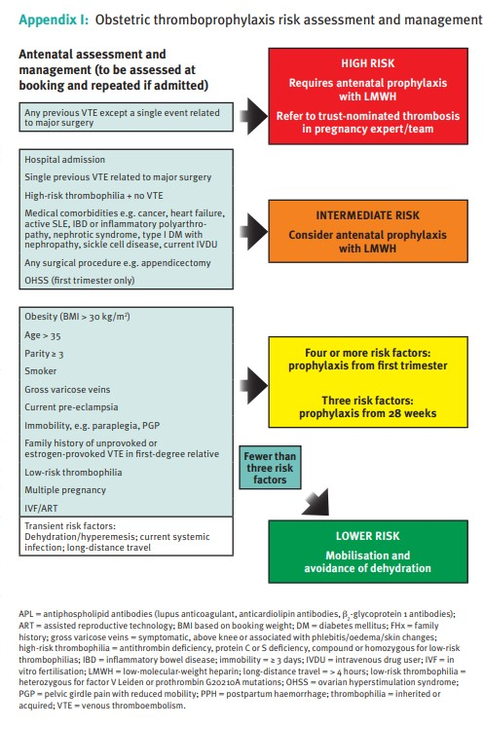

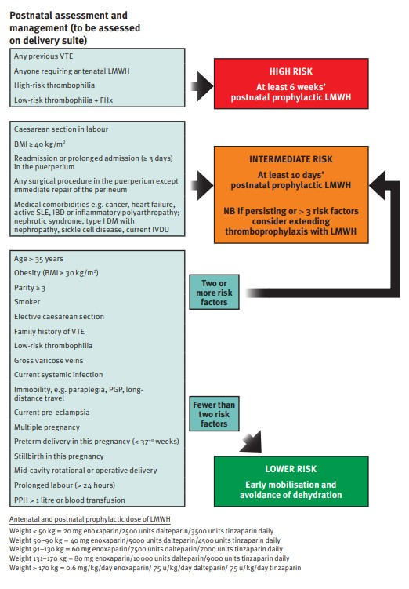

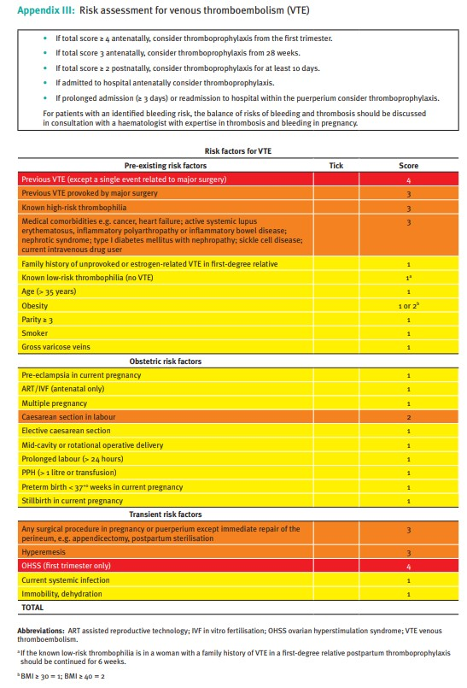

THROMBOPROPHYLAXIS FOR POSTNATAL INPATIENTS

Patients who have delivered in the past 6 weeks are at increased risk of

thrombosis.

LMWH thromboprophylaxis is required during

**any**

admission to hospital during this time

**unless**

there is a contraindication

**Is there a contraindication to enoxaparin?**

•

Bleeding disorder

-

contact haematology

•

Active bleeding

•

Increased risk of

major bleeding

•

Platelets< 50

•

Stroke within 4 weeks

•

Severe renal disease*

•

Severe liver disease (contact Hepatology)

•

Uncontrolled hypertension

•

Allergy to heparin/HIT

-

contact

haematology

*Thromboprophylaxis can be prescribed but will

need dose adjustment if c

reat

inine

clearance

<30

mi/min

YES

•

DO NOT prescribe

LMWH

•

Document reason for

decision in the medical

notes

•

Consider mechanical

thromboprophylaxis

No

|  |  |  |  |  |  |  |  |  |  |  |  |  |  |  |  |  |  |  |  |  |  |
| --- | --- | --- | --- | --- | --- | --- | --- | --- | --- | --- | --- | --- | --- | --- | --- | --- | --- | --- | --- | --- | --- |
| |  |  |  |  |  |  |  |  |  |  |  |  |  |  |  |  |  |  |  | | --- | --- | --- | --- | --- | --- | --- | --- | --- | --- | --- | --- | --- | --- | --- | --- | --- | --- | --- | | |  |  |  |  | | --- | --- | --- | --- | | Please note that dosing of enoxaparin in pregnancy and the postpartum period is different and should follow RCOG guidelines a s below: | | | | | Weight (Kg) | Enoxaparin dose (mg) | | <50 | 20mg OD | | 50-9- | 40mg OD | | 91-13- | 60mg OD | | 131-170 | 80mg OD | | >170 | 0.6mg/Kg OD | |  |  |   *Dose adjustment needed if creatinine clearance is <30ml/min | | |  | | --- | | **If unsure, discuss with a**  **Consultant Obstetrician** | |

Thromboprophylaxis for antenatal inpatients

|  |  |  |  |  |  |  |  |  |  |
| --- | --- | --- | --- | --- | --- | --- | --- | --- | --- |
| |  | | --- | | **Is there a contraindication to Enoxaparin?**  **>**Known bleeding disorder-contact haematology  >Active bleeding  >Increased risk of major haemorrhage  >Thrombocytopenia (platelet count<50x109/1)  >Acute stroke with the last 4 weeks  >Severe renal disease*  >Severe liver disease (discuss with Hepatology)  >Uncontrolled hypertension (BP≥220/120)  >Placenta praevia with bleeding risk  >Allergy to heparin/ HIT-contact haematology  *Thromboprophylaxis can be prescribed but will need dose adjustment if creatinine clearance <30ml/min | | YES | | |  |  |  |  | | --- | --- | --- | --- | | |  | | --- | | **DO NOT prescribe LMWH** | | Document decision in the medical notes | | Consider mechanical thromboprophylaxis | | | |
| No | | | Yes | | |  | | --- | | * **DO NOT prescribe**   **LMWH**   * Document decision in the medical notes * Consider mechanical thromboprophylaxis | | |
| |  | | --- | | Are there any signs of active labour?  Or  Is induction planned within the next 12 hours? | | | |
| No    •    Offer LMWH  prophylaxis    •    Review daily on the ward round or if the  clinical situation changes    Weight (Kg)    Enoxaparin    dose    <50    20  mg OD    50  -  90    40  mg OD    91  -  130    mg OD  60    131  -  170    mg OD  80    >170    0.6  mg/Kg per  day      *Dose adjustment needed if creatinine  clearance <30ml/min | | |
| |  | | --- | | **If unsure, discuss with Consultant Obstetrician** | | | | |